SLOCAN COMMUNITY LIBRARY
Upcoming Author Presentation
Judy Pollard, Kootenay author of “The Distance- Dreams & Despair” will be discussing her novel.
Saturday, 1pm
March 14th 2026
We have this book on the new fiction shelf in the library.

LEGION CALENDAR

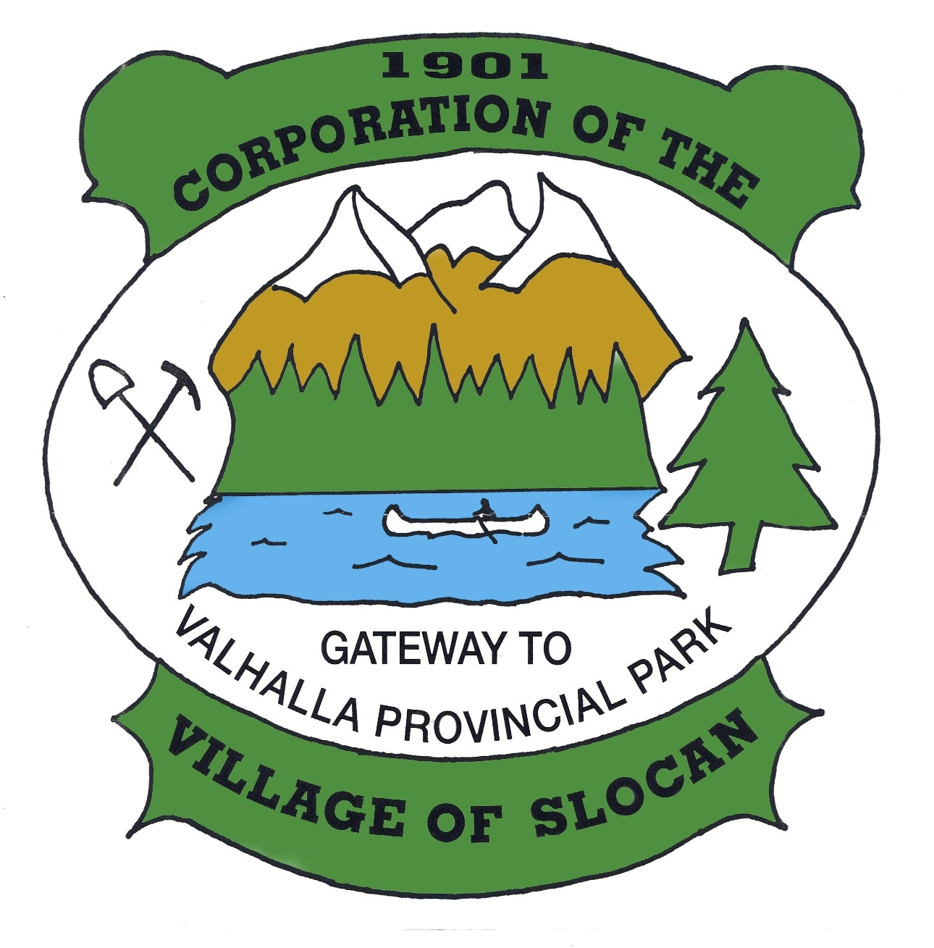
OFFICE HOURS:
Monday to Thursday from
9:00am to 4:00pm
(Closed from 12 noon to
1:00pm for lunch)
Closed on Fridays.
THE CORPORATION OF
THE VILLAGE OF SLOCAN
Box 50, 503 Slocan Street, Slocan, B.C. V0G 2C0
Ph: 250-355-2277 | Fax: 250-355-2666
info@villageofslocan.ca
February 2026 - NEWSLETTER

FRIDAY NIGHT DANCE
& VALENTINE DINNER
Friday Feb 13th- 6:00 – 9:00pm
Live music from Cabin Fever & Food by Talishak
VALENTINE’S DANCE
Saturday Feb 14th- 9:00pm – 1:00am
With Adham Shaikh & Wax Headroom
Legion Facebook Page
SENIORS LUNCH
Tuesday Feb 24th- 11:00am – 2:00pm
WEGCSS
TEXAS HOLD’EM
Saturday Feb 28th 6:30pm
Legion Facebook Page
MEAT DRAW SUNDAYS
Every Sunday - 4:30-6:00 pm
Legion Facebook Page
SUNDAY OPEN MIC NIGHT
Every Sunday - 4:00pm
Legion Facebook Page

2026 Council Meeting Schedule
January 12 May 11 September 14
February 9 June 8 October 13 (Tues.)
March 9 July 13 November 9
April 13 August 10 December 14

FEBRUARY

(Council Meetings start at 7:00 pm in Village Chambers unless otherwise posted.)

Missed the last meeting? No problem! Agendas and minutes are available on the Village website: www.slocancity.com/council
The next Regular Council Meeting will be held on MARCH 9th 2026 at 7:00pm
To attend a public meeting, please use the following link to attend virtually, or by telephone: https://global.gotomeeting.com/join/322545565 or dial in by phone: 1-647-497-9391 Access Code 322-545-565


LIBRARY HOURS ARE:
Thur. 1pm - 5pm / Fri. 7-9pm - Tea & Chat
Sat. & Sun. 11am - 3pm

Come in and browse or search our catalog online at: www.slocanlibrary.ca We are located at 710 Harold St. Slocan, BC

p

LOOKING FORWARD TO THE SEASON!
THE SPRINGER CREEK RV PARK & CAMPGROUND ONLINE BOOKING SYSTEM WILL BE
OPEN AT 12PM ON MARCH. 2nd 2026

BILLS NOW DUE:
BUSINESS LICENSES: Billed Dec. 15th…… Due Jan. 31st 2026

DOG LICENSING: Billed Dec. 15th …… Due Jan. 31st 2026

UTILITIES (WATER/GARBAGE): Billed Jan. …. Due Mar. 2nd 2026
*Please contact the Village Office to inquire about your balance.
ON JANUARY 1st, 2027, ALL OUTSTANDING BALANCES ON UTILITY BILLS WILL BE TRANSFERRED TO ARREARS TAXES.

BUILDING INSPECTION SERVICES
The building inspector is at the Village
Office every Thursday at 9:30am. If you wish
to make an appointment please call:
250-355-2277 BEFORE THURSDAY.

Newsletter images from Pixabay.com


250.355.2277 | www.slocancity.com |  www.facebook.com/villageofslocan

NEIGHBOURHOOD
SMALL GRANTS

VILLAGE OF SLOCAN MEETING NOTES – February 9th Regular Meeting

, 2016
- Eden DuPont and Rachel Nissenbaum, on behalf of the Osprey Community Foundation, presented information on the Neighbourhood Small Grants Program.
- Council received the 2025 Year End Building Permit Report and Fitness Centre Report.
- Mayor Lunn and Councillors Knott, Buller, and Perriere will attend the Annual AKBLG Conference in Trail, BC on April 17-19, 2026.
- A Public Input Meeting will be held on April 20, 2026 at 5:00pm, at which time applicants will be invited to give a 5-minute presentation of their ReDi Grant applications, and answer any questions. A Special Meeting will be scheduled on April 27, 2026 at 6:00pm to deliberate the allocation of funds.
- Council awarded $1,000 from the RDCK Community Development Grant Fund to the Okanagan Nation Alliance, for their 2026 Fish in Schools Program.
- Statistics Canada is recruiting workers for the 2026 Census. Info will be posted out in the Newsletter.
- The Village will send a letter to Steller Vista Credit Union, expressing its disappointment regarding the cancellation of the Village’s tax and utility pre-payment plan.
- Council received a staff report and rate comparison for the Springer Creek RV Park & Campground. Rates are proposed to be increased by a nominal amount for the 2026 season.
- Council received a staff report and rate comparison for the Slocan Cemetery. Rates are proposed to be increased by a nominal amount.
- The first three readings were given to the Slocan Fees & Charges Amendment Bylaw, and Cemetery Bylaw. Adoption is scheduled for February 18th.
- A Special Meeting is scheduled for Wednesday Feb18th at 6:00pm to adopt the Cemetery Bylaw and Fees & Charges Amendment Bylaw. Council will also be discussing the campground contract, mill site loan, and will be reviewing the Animal Control Bylaw.

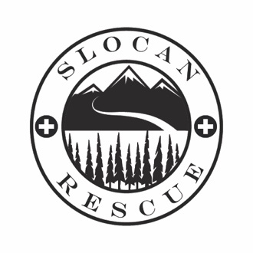

2026 will be Osprey’s seventh year participating in the Neighbourhood Small Grants (NSG) program. The NSG program provides grants for individuals to share their gifts and bring together their communities. Grants can be up to a maximum of $500 and are awarded to individuals. In 2025, Osprey awarded $4575 to Slocan Valley residents, and included projects held in Slocan such as the Friday Night Live and Slocan Village Summer Showcase.
Anyone from the Nelson community & RDCK areas E and F, North Kootenay Lake, Salmo Valley and Slocan Valley, is eligible to apply for
NSG of up to $500.
2026 Applications open
March 2nd to April 14th!
For more information
please visit:
www.neighbourhoodsmallgrants.ca/

THE NEW DENVER
MEDICAL CLINIC
is open for Slocan residents at the SLOCAN WELLNESS CENTRE on WEDNESDAY’S from 10am-3pm. To book an appointment please call: 250-358-7211

COLUMBIA BASIN TRUST ReDi GRANTS
The application for 2026 ReDi Grants is STILL open and closes on February 20, 2026.
For more details on how to apply and information about opportunities for public engagement and reporting requirements contact the RDCK directly or visit their website.
Contact Name: Monique St Louis, Grants Coordinator E: grants@rdck.bc.ca P: 1.250.352.8170
Keep up to date on Village business by attending regular Council meetings, or by visiting our website or Facebook page:

ELECTRONIC PAYMENTS: Did you know that you can pay your property tax and utility bills online? The service is not yet available through some financial institutions, but those who bank with a credit union or BMO will have full access immediately. When creating the Village as a vendor, please do not include the zeros with the account numbers. For any assistance with electronic payments, feel free to contact the Village Office. 355-2277. PLEASE NOTE: If you are paying by
telpay we will need notification of the account name and number the payment is allocated to.

250.355.2277 | www.slocancity.com | www.facebook.com/villageofslocan

REMINDER: ITEMS SUBMITTED FOR INCLUSION ON THE COUNCIL MEEETING AGENDA MUST BE RECEIVED NO LATER THAN 12-NOON,
7 DAYS IN ADVANCE OF THE MEETING. LATE ITEMS WILL NOT BE ACCEPTED AND WILL BE INCLUDED ON THE NEXT MEETING AGENDA.

