ANNUAL GENERAL MEETING
Wednesday April 29 at 7p.m.
710 Harold Street, Slocan.
We value your input. Financial reports, lending statistics. Please come out and vote.
We value your input. Financial reports, lending statistics. Please come out and vote.

SENIORS LUNCH
APRIL 21st - 11:00am – 2:00pm
WEGCSS
TAPS PROGRAM
EVERY WEDNESDAY 11:00am
Promoting Seniors Wellbeing
danielle@wegcss.org
FRIDAY NIGHT DINNER & DANCE
APRIL 17th 7:00-9:00pm
Food by Shared Flame 5:30-8:00pm
Legion Facebook Page
FRIDAY NIGHT KARAOKE
APRIL 24th 6-10:00pm
Pizza by Luv Affair
Legion Facebook Page
SUNDAY OPEN MIC NIGHT
EVERY SUNDAY 4:00-7:00pm
Legion Facebook Page
MOTHERS DAY PANCAKE BREAKFAST
SUNDAY MAY 10th 8:30-11:30am
LEGION CALENDAR

SLOCAN COMMUNITY LIBRARY

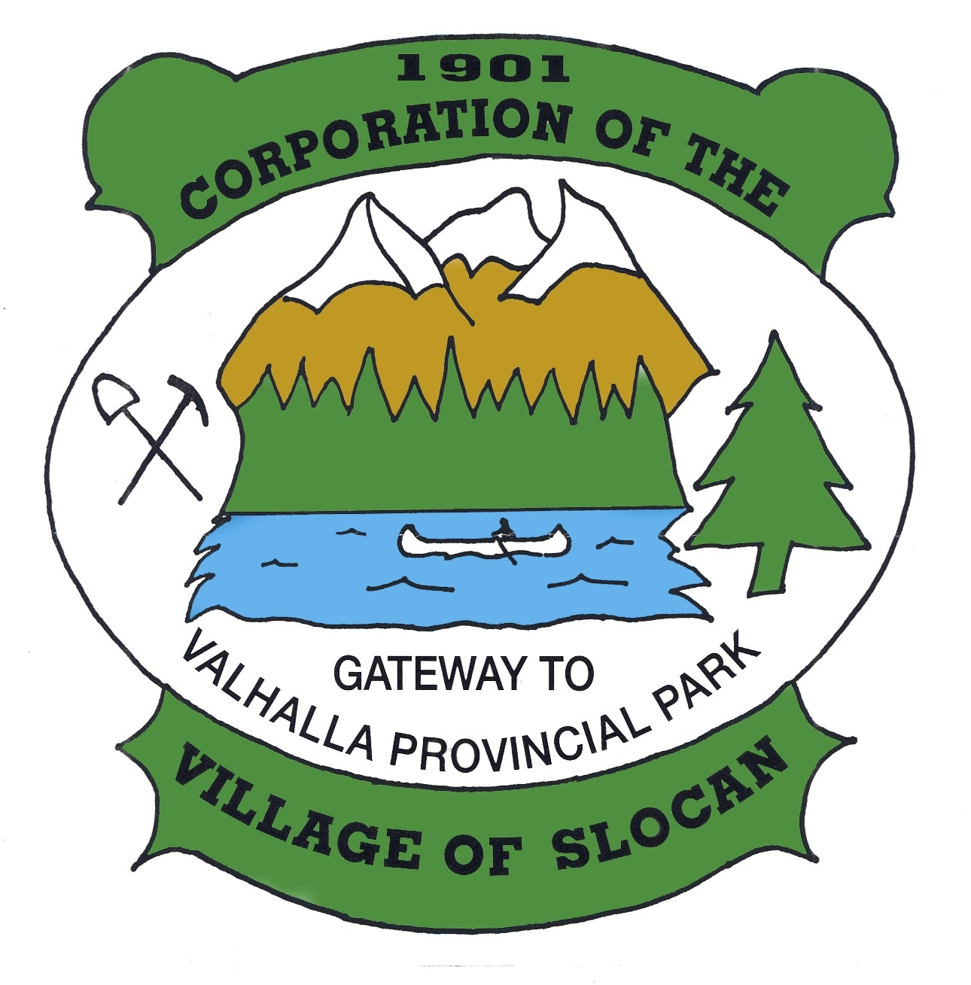
OFFICE HOURS:
Monday to Thursday from
9:00am to 4:00pm
(Closed from 12 noon to
1:00pm for lunch)
Closed on Fridays.
THE CORPORATION OF
THE VILLAGE OF SLOCAN
Box 50, 503 Slocan Street, Slocan, B.C. V0G 2C0
Ph: 250-355-2277 | Fax: 250-355-2666
info@villageofslocan.ca
April 2026 - NEWSLETTER

2026 Council Meeting Schedule
January 12 May 11 September 14
February 9 June 8 October 13 (Tues.)
March 9 July 13 November 9
April 13 August 10 December 14

APRIL

(Council Meetings start at 7:00 pm in Village Chambers unless otherwise posted.)

Missed the last meeting? No problem! Agendas and minutes are available on the Village website: www.slocancity.com/council
The next Regular Council Meeting will be held on MAY 11th 2026 at 7:00pm
To attend a public meeting, please use the following link to attend virtually, or by telephone: https://global.gotomeeting.com/join/322545565 or dial in by phone: 1-647-497-9391 Access Code 322-545-565



Neighbourhood Garage Sale
Saturday, May 23 from 9am -3pm
Maps, book sale and coffee inside the library and
Grassroots Grammas' tables on the lawn from 9am-1pm.

LIBRARY HOURS ARE:
Thur. 1pm - 5pm / Fri. 7-9pm - Tea & Chat
Sat. & Sun. 11am - 3pm

LOOKING FORWARD TO THE SEASON
THE SPRINGER CREEK RV PARK & CAMPGROUND ONLINE BOOKING SYSTEM IS NOW OPEN
and the campground will be
OPEN ON FRIDAY MAY 1st 2026
We look forward to seeing you again soon!

BUILDING INSPECTION SERVICES
The building inspector is at the Village
Office every Thursday at 9:30am. If you wish
to make an appointment please call:
250-355-2277 BEFORE THURSDAY.

Newsletter images from Pixabay.com


| www.facebook.com/villageofslocan

Understanding the building permit process in the RDCK

Spring is right around the corner and typically it is a busy time for builders and home owners to break ground on new projects.
Obtaining a building permit through the RDCK is a straightforward process when applicants are prepared. This is a collaborative effort between the community and the local government. To avoid delays, applicants are encouraged to plan at least three months ahead of their intended construction start date and ensure they submit a complete and compliant submission.
The most common setbacks stem from engineering requirements from complex designs, misunderstandings around bylaws, development variances or zoning requirements, and failing to confirm whether a permit is required.
The first step is to review the RDCK building brochure and, if uncertain, contact staff. The Village Office conducts preliminary checks to ensure the permit meets the relevant zoning requirements before the RDCK Building Officials approves that the permit meets all building code requirements and standards. For more information please visit the Building Department | Regional District of Central Kootenay and the Village of Slocan’s Zoning Bylaws

- Council will provide a $1,382.37 RDCK Community Development Grant to the Slocan Legion, representing a Grant-in-Aid for 50% of the Hall’s heating costs throughout the months of December 2025 to March 2026.
- Council approved the Slocan Village Market’s request to proceed with temporary landscape and parking improvements on Village road right-of-way along Ward Avenue, directly adjacent to 519 Harold Street, including parking area levelling and road crush, cub-style concrete barriers to establish angled parking stalls, and a paving stone path and seating area.
- The request from Lisa Parente of Treehugger Events Society, to use of the Slocan Beach to host a festival at the Slocan beach from Friday, July 3rd to Sunday, July 5th, 2026, was approved pending submission of a completed Special Events Application, proof of insurance, and all other Village requirements. The village will cover the cost of one portable toilet through the RDCK Community Development Fund and the beach washrooms are permitted to be used during the festival, provided that organizers be responsible for cleaning and maintenance.
- Council approved in principle, the Slocan Valley Historical
Society’s Request to make improvements to the Steam Winch
Display at the Slocan Campground, pending submission of a
workplan and design plans.
- Council approved closure of a one-block section of Harold Street,
from Ward Avenue to Delany Avenue, on Saturday, July 18th
after 11:00am for the 125th Birthday Celebrations. Council
awarded $5k from the RDCK Community Development Fund to
the event.
- Staff were directed to look into the FCM New Trees to Enhance
Your Community Program as a potential contribution to the
Harold Street Project.
- Council gave first three readings to the Loan Authorization Bylaw
and staff were directed to submit to the Inspector of Municipalities
for approval.

VILLAGE OF SLOCAN MEETING NOTES – April 13th

, 2016

WEST KOOTENAY FOOTBALL CLUB
Is very happy to announce their first big game day back at the Expo Park on May 2nd 2026
For more info contact:
www.West Kootenay Football.com

ATTENTION
SLOCAN FITNESS CENTER USERS
You will now be required to enter your monthly door code on the main entrance door AND on the inner gym door in order to access the fitness center. Please have your Fitness Center Pass on you at all times while using the facilities.
THANK YOU!

REMINDER: ITEMS SUBMITTED FOR INCLUSION ON THE COUNCIL MEEETING AGENDA MUST BE RECEIVED NO LATER THAN 12-NOON,
7 DAYS IN ADVANCE OF THE MEETING. LATE ITEMS WILL NOT BE ACCEPTED AND WILL BE INCLUDED ON THE NEXT MEETING AGENDA.

Keep up to date on Village business by attending regular Council meetings, or by visiting our website or Facebook page:

THE NEW DENVER
MEDICAL CLINIC
is open for Slocan residents at the
SLOCAN WELLNESS CENTRE
on WEDNESDAY’S 10am-3pm.
To book an appointment please
call: 250-358-7211

250.355.2277 | www.slocancity.com |  www.facebook.com/villageofslocan

