FRIDAY August 21st
DINNER & DANCE with Diamond Willow
7-9pm /$5 Cover
Food by Shared Flame 6-8pm
SUNDAY August 23rd
OPEN MIC & MEAT DRAWS 4-7pm
Food by Shared Flame
FRIDAY August 28th
DINNER & KARAOKE 7-9pm / $5 Cover
Food by Shared Flame 6-8pm
SUNDAY August 30th
OPEN MIC & MEAT DRAWS 4-7pm
Food by Shared Flame
LEGION CALENDAR

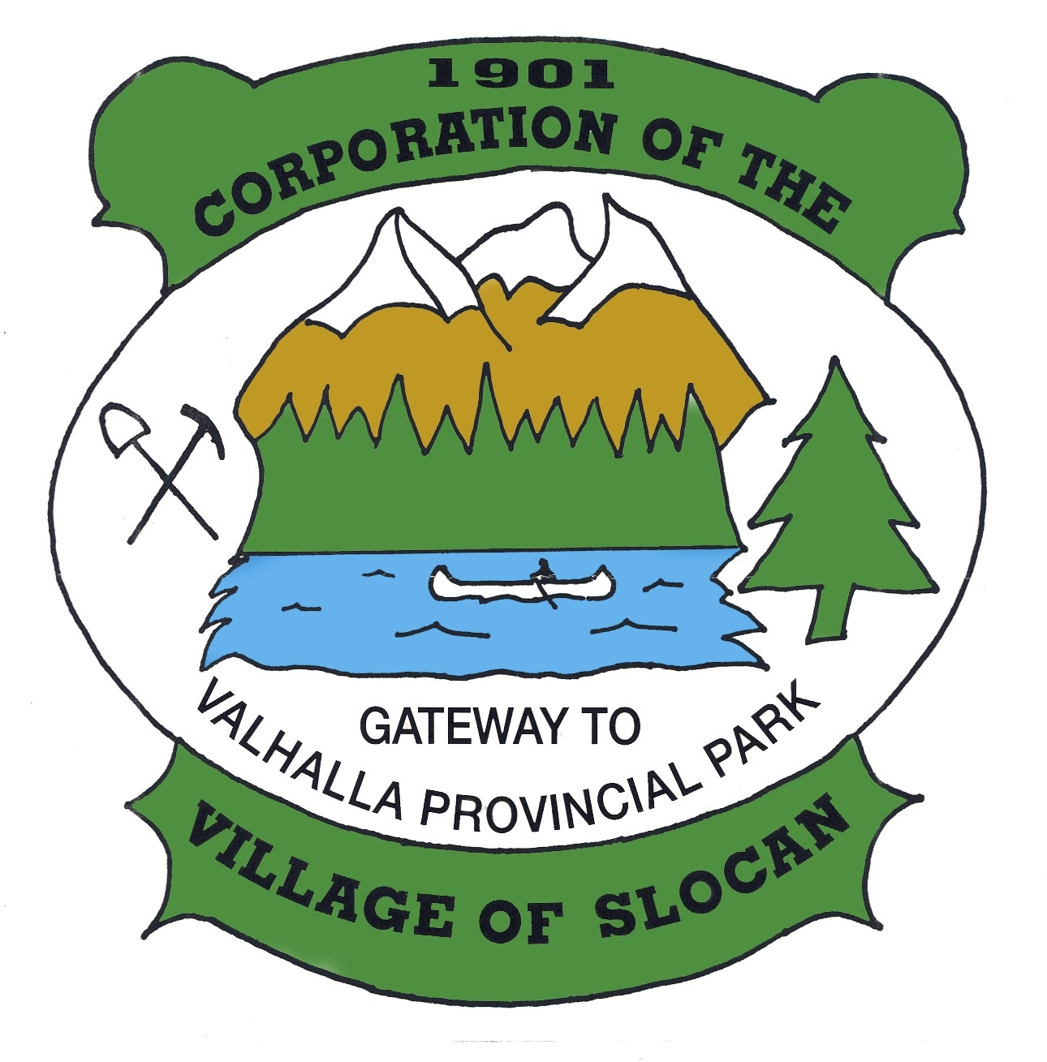
OFFICE HOURS:
Monday to Thursday from
9:00am to 4:00pm
(Closed from 12 noon to
1:00pm for lunch)
Closed on Fridays.
THE CORPORATION OF
THE VILLAGE OF SLOCAN
Box 50, 503 Slocan Street, Slocan, B.C. V0G 2C0
Ph: 250-355-2277 | Fax: 250-355-2666
info@villageofslocan.ca
August 2026 - NEWSLETTER

Volunteers will keep the library open all summer:
Saturdays and Sundays 11 a.m. to 3 p.m.
Thursdays 1 to 5 p.m.
Fridays 7 to 9 p.m.

Come out for 'Books and Hooks'
on Friday’s!

AUGUST

2026 Council Meeting Schedule
January 12 May 11 September 14
February 9 June 8 October 13 (Tues.)
March 9 July 13 November 9
April 13 August 10 December 14

There are 'beach books' free to take from the front steps and by donation in the back
hallway.

(Council Meetings start at 7:00 pm in Village Chambers unless otherwise posted.)

Missed the last meeting? No problem! Agendas and minutes are available on the Village website: www.slocancity.com/council
The next Regular Council Meeting will be held on SEPTEMBER 14TH 2026
To attend a public meeting, please use the following link to attend virtually, or by telephone: https://global.gotomeeting.com/join/322545565 or dial in by phone: 1-647-497-9391 Access Code 322-545-565
And our website has a new look
visit slocanlibrary.ca for books
for people of all ages.

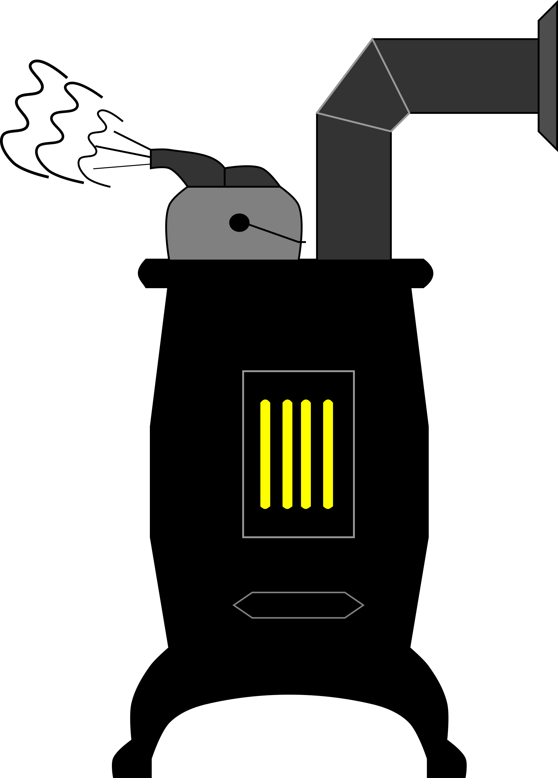

THINKING ABOUT RUNNING FOR VILLAGE COUNCIL?

Nomination Period is now open!
Packages will be available at the Village Office until the close of the period, September 11th 2026.
To qualify for Office, you must be a Canadian Citizen, 18 years of age or older, resident of BC for at least 6 months immediately before the nomination papers are filed, and not disqualified by law.

CAMPFIRE BAN
IN EFFECT UNTIL FURTHER NOTICE NO:
CAMPFIRES, OPEN BURNS, SKY LANTERNS OR FIREWORKS.
Fines are $1150.00 and are being given without hesitation. PROPANE CAMPFIRES PERMITTED WITH FLAMES LIMITED TO 15cm.

2026 ONA PROGRAM ~~ WRAP-UP ~~

The Columbia FinS Program has concluded for this season with the school’s fry releases joining the Syilx Fry Release Ceremonies in May, represented by 27 schools from 5 Columbia School Districts.
Heartfelt thanks to all of you for your continued support and dedication to the Program!!

Slocan Beach/Park at Slocan Lake – 200+ students & attendees. Hatchery truck with additional Salmon Fry.

SPRINGER CREEK RV PARK AND
CAMPGROUND IS OPEN
For online reservations and information
please visit the campground page at: www.slocancity.com
E: campground@villageofslocan.ca

Sprinkling permitted daily between the hours of:
7:00am to 9:00 am
AND
6:00 pm to 8:00 pm
ONLY

BUILDING INSPECTION SERVICES
The building inspector is at the Village
Office every Thursday at 9:30am.
If you wish to make an appointment
please call:
250-355-2277 BEFORE THURSDAY.
Our water reservoir relies on the down-time during the night to refill.
Please ensure you’ve turned your sprinklers off at night!

In advance of the General Local Elections being held this coming October, please visit the link below to confirm your name and address for the Voter’s Registration List:
https://eregister.electionsbc.gov.bc.ca/ovr/
welcome.aspx

Newsletter images from Pixabay.com


| www.facebook.com/villageofslocan

CALL TO COMMUNITY
Local government elections are just around the corner, and with them comes an opportunity to help shape the future of our community. Have you ever wondered what it’s really like to serve on Village Council?
Or maybe someone has encouraged you to run, but you’re not sure what’s involved?
The free Candidate Readiness Workshop is a great place to start. You’ll get a practical look at what elected officials actually do, how local decisions are made, and what to consider before putting your name forward. Whether you’re thinking about running this year or simply want to better understand local government, everyone is welcome.
Tuesday, August 18
Attend in Castlegar or join online at 6:00 p.m.
Strong communities don’t happen by accident. They are built by ordinary people who choose to step forward, ask good questions, and care deeply about the places they call home.
If you’ve ever felt a quiet nudge to contribute in a bigger way, this might be the opportunity to explore what that could look like.
Learn more: https://castlegar.ca/workshop

VILLAGE OF SLOCAN MEETING NOTES – August 10th

, 2016
- The Quarterly Financial Report ending June 30, 2026, prepared by the CFO, was received.
- The Local Government Climate Action Report for 2025 was received.
- Council directed staff to amend the Halloween Hoot Committee Terms of Reference to include a $500 honorarium for the Certified Display Fireworks Supervisor, and $100 to the Fireworks Assistance (up to a maximum of five). A $5,500 RDCK Community Development Grant was awarded to offset event expenses for 2026.
- The Village of Slocan will provide $1000 from the RDCK Community Development Grant Fund, to the West Kootenay Boundary Caregiver Support Program in New Denver, to assist with implementation of the Regional Online Caregiver Peer Support Program.
- The “Village of Slocan Permissive Tax Exemption Bylaw (2027-2029) was adopted.
- The start time for the regular meeting of August 10th, 2026 was changed from 7:00pm to 6:00pm at the In-Camera meeting of August 6th. Staff posted notice; and it was further resolved be moved to open meeting.

vi
Please sign up and help us continue our annual
Halloween extravaganza!!
OUR MISSION: To support and promote the Slocan Valley business community.
VISION: A vibrant, diverse and healthy economy that respects the environment and community values of the Slocan Valley.
BECOME A MEMBER NOW!
Volunteers needed for the Halloween Hoot Committee 2026
Saturday October 31st will be our 34th Annual Fireworks Display.

Call the village office:250-355-2277

NOTICE OF 2026 TAX SALE
Pursuant to Part 11 of the Local Government Act, all Local Governments must conduct an Annual Municipal Tax Sale – a sale by public auction – of each parcel of real property on which taxes are delinquent.
If property owners have outstanding delinquent balances as of MONDAY, SEPTEMBER 28th, 2026 at 10:00am,
the properties will be listed and sold in the public auction.
on MONDAY, September 7th. 2026
for LABOUR DAY
Regular hours will resume on Tuesday, September 8th at 9:00am

FREE N95 MASKS AVAILABLE - At the Village Office
Due to the current wildfire smoke in our area, the Village is offering free N95 masks to those who may need one. Masks are limited to 2 per person, and are available at the Village Office during regular business hours.

---
THE NEW DENVER
MEDICAL CLINIC
is open for Slocan residents at the
SLOCAN WELLNESS CENTRE
on WEDNESDAYS 10am-3pm
For appt. please call:
250-358-7211

Keep up to date on Village business by attending regular Council meetings, or by visiting our website or Facebook page:

250.355.2277 | www.slocancity.com |  www.facebook.com/villageofslocan

REMINDER: ITEMS SUBMITTED FOR INCLUSION ON THE COUNCIL MEEETING AGENDA MUST BE RECEIVED NO LATER THAN 12-NOON,
7 DAYS IN ADVANCE OF THE MEETING. LATE ITEMS WILL NOT BE ACCEPTED AND WILL BE INCLUDED ON THE NEXT MEETING AGENDA.

